# CREATE A SERVICE CALL - STANDARD

**ENABLE NAXT ATTACHMENT STATUS**

## Introduction

In NAXT, you can attach a file to a database record like equipment, customer or a service call, with the Document Handling function. Anyone in NAXT can then retrieve that file. You can view the QRG on how to attach and retrieve a file [here](http://intra/files/qrg---document-handler---march-2016-pdf-Xr7HxN.pdf).

To easily tell if a database record has an attachment, you’ll need to turn on attachment status.

## ENABLE ATTACHMENT STATUS

**Step 1: Navigate to NAXT options**

Select ‘File’ to reveal a drop down menu; select ‘Tools’ then ‘Options’.

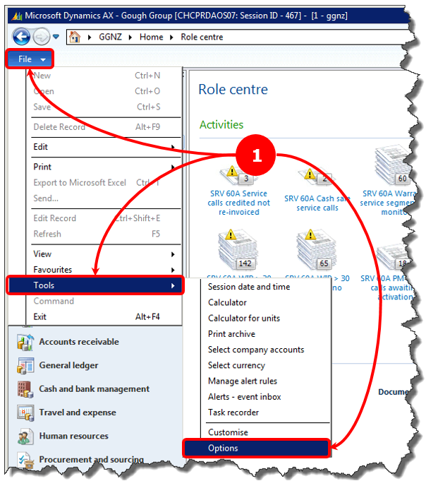

**Step 2: Enable the attachment indicator**

Select the ‘Miscellaneous’ fast tab, then the ‘‘Show attachment status’ checkbox. Select ‘Close’.

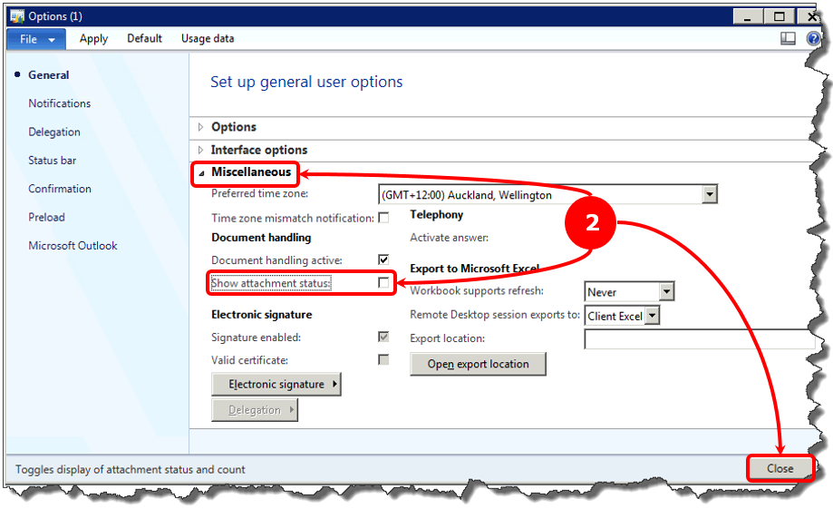

## HOW TO SEE IF AN ATTACHMENT EXISTS

**Step 3: Highlight a data record line**

In a data record list view (like service calls or equipment), select the line you want to check out.

Look at the ‘attachments’ icon in the ribbon tab. If the icon has a yellow background, your selected data record has an attachment.

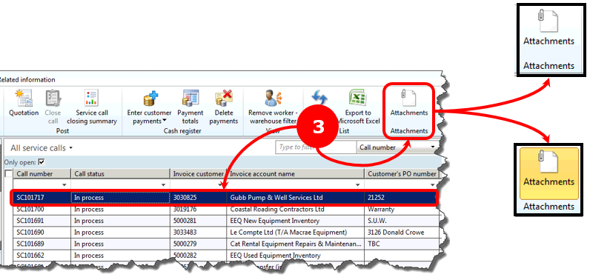

## HOW TO VIEW AN ATTACHMENT

**Step 4: View an attached document**

4A: Select the ‘Attachments’ button; the ‘Document handling’ window will pop up.

4B: Select the document you want to view.

4C: Select the ‘Open’ button and the document will open as a PDF.

